TNP Application  Tennessee Naturalist Program  Chattanooga Chapter  Chattanooga Audubon Society | 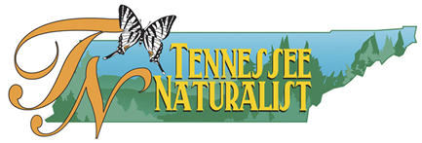

Contact Information
Name
Street Address
City ST ZIP Code
Home Phone
Work Phone
E-Mail Address

Person to Notify in Case of Emergency
Name
Street Address
City ST ZIP Code
Home Phone
Work Phone
E-Mail Address

Our Policy

It is the policy of this organization to provide equal opportunities without regard to race, color, religion, national origin, gender, sexual preference, age, or disability.

Thank you for completing this application form and for your interest in volunteering with the Tennessee Naturalist Program.

Payment Information
Registration fee for the course is $250. This covers all course materials and first year registration into the Tennessee Naturalist Program. Payment can be made at www.ChattanoogaAudubon.org, at the Audubon Acres visitor center, or by mail at the address below.
Please make checks out to: Chattanooga Audubon Society

Mailing Address
Chattanooga Audubon Society
Attn: Tennessee Naturalist Program
900 North Sanctuary Rd.
Chattanooga, TN 37421
____________________________________________________________________________________
Office information:
Paid? Yes No

2018/2019 Program Schedule

Date Time Topic Guest Speaker
Aug 18 9am-1:30pm So You Want to be a Naturalist Sunny Montgomery
Lunch Provided After Session

Sept 15 9am-1pm Water Quality and Mariah Prescott
Macroinvertebrates Sunny Montgomery

Oct 13 9am-1pm Ecology and Geology Margie Hunter

Nov 10 9am-1pm Plants and Dendrology Tom Stebbins
Ken Clark

Dec 15 4pm-9pm Nocturnal Naturalist Matt Harbison
6pm-7pm Dinner Break Gillian Roberts

Jan 19 9am-1pm Mammals TBA

Feb 16 9am-11am Insects (classroom) Julia Gregory

Mar 16 9am-1pm Ferns and Fungus Chet Perry

April 6 9am-11am Insects (field work) Julia Gregory

Apr 20 9am-1pm Ornithology David Aborn

May 25 9am-1pm Herpetology Paul-Erik Bakland

*Schedule is subject to change.

